**LRFFC 8**Selects the correct item from an array of 8,

for 25 different LRFFC fill-in statements of any type.

1. “You sleep in a ___”

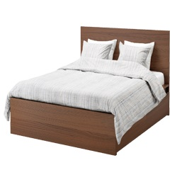

1. “You climb a ___”

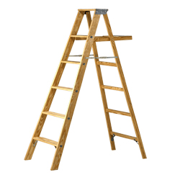

1. “You swim in a ___”

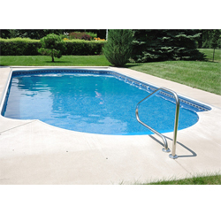

1. “You knock on the ____”

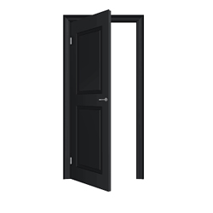

1. “You blow up a ____”

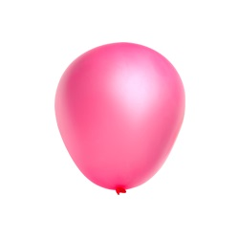

1. “You Jump on ___”

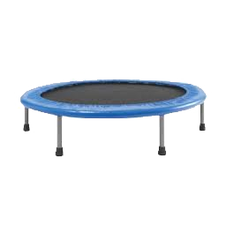

1. “You sit in a___”

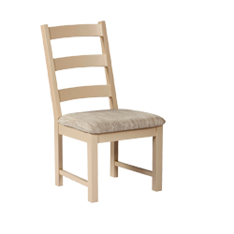

1. “You write in a __”

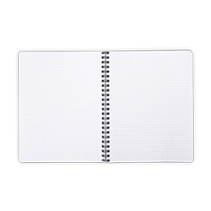

1. “You cook in a ____”

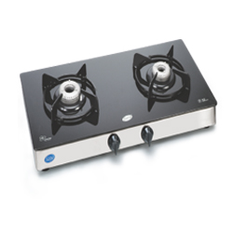

1. “You eat __”

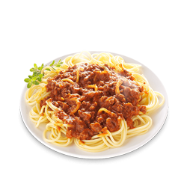

1. “You drink ___”

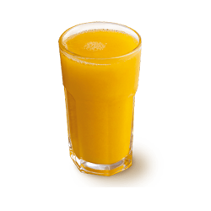

1. “You live in a ___”



1. “You read a ___”



1. “You watch on the ____”

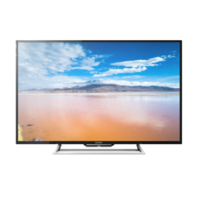

1. “You wear a ____”

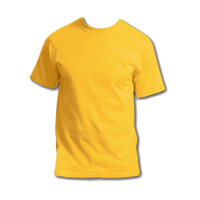

1. “You brush your ____”

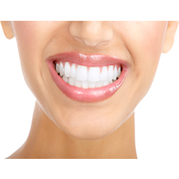

1. “You wash your ____”

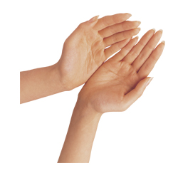

1. “ You bake ___”

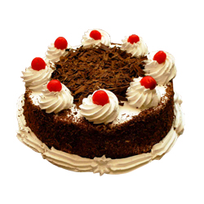

1. “ You pee in the ____”

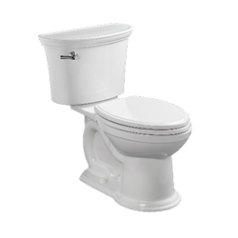

1. “ You drive a ____”

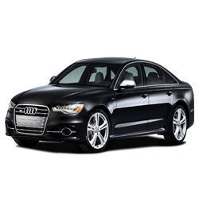

1. “ You take photos using ____”

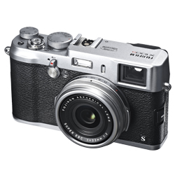

1. “You walk on the ___”

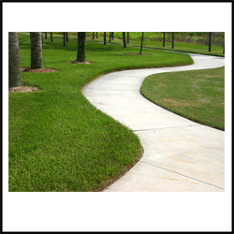

1. “You call using ___”

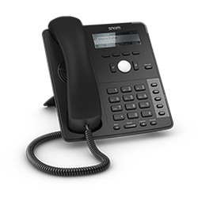

1. “You bounce a ___”



1. “You comb your ___”

